Sumit Vadaviya

Camunda BPM Expert, Corporate Trainer

Email : sumit.vadaviya@trainosoft.com

I

n this session we will do default installation of camunda

# **1. Software required**

1. Download Community version of Camunda camunda-bpm-tomcat-7.14.0.zip

[Camunda 7.14.0](https://camunda.com/download/)

1. Download JDK 8.

[JDK 8](http://www.oracle.com/technetwork/java/javase/downloads/jdk8-downloads-2133151.html)

# **2. Installation**

**2.1 Java**

Before downloading Camunda, make sure you have a JRE (Java Runtime Environment), or better, a JDK (Java Development Kit) installed. We recommend using Java 8.

Camunda Installation

C:\Users\Sumit>java -version

java version "1.8.0_60"

Java(TM) SE Runtime Environment (build 1.8.0_60-b27)

Java HotSpot(TM) 64-Bit Server VM (build 25.60-b23, mixed mode)

C:\Users\Sumit>javac -version

javac 1.8.0_60

**2.2 Camunda**

* Download Camunda camunda-bpm-tomcat-7.14.0.zip

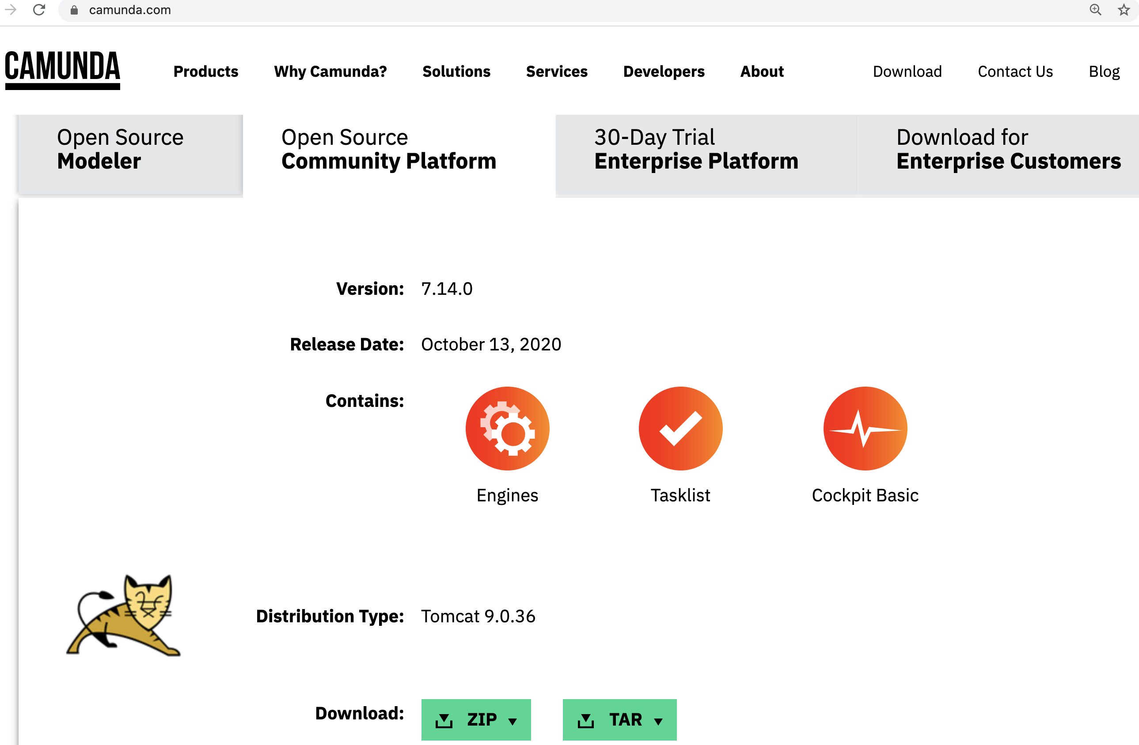

You will see a page as shown above. The community platform with 7.14.0 version. you will see two formats for downloading the camunda deployer i.e. ZIP and TAR.

Download the file either in ZIP or TAR format.

* Extract camunda-bpm-tomcat-7.14.0.zip
* Navigate to H:\CAMUNDA\camunda714 where camunda-bpm-tomcat-7.14.0.zip is extracted
* Start the camunda using command prompt.
* H:\CAMUNDA\camunda714/camunda-bpm-tomcat-7.14.0>start-camunda.bat

This camunda deployer is used to deploy the business processes. By default this package comes with the tomcat server on which the camunda deployer runs. The H2 database is used for the initial startup process. You can change it to different database as per your requirement.

# **3. Accessing Camunda**

Camunda application can be accessed from **[http://localhost:8080/camunda/](http://localhost:8090/camunda/)**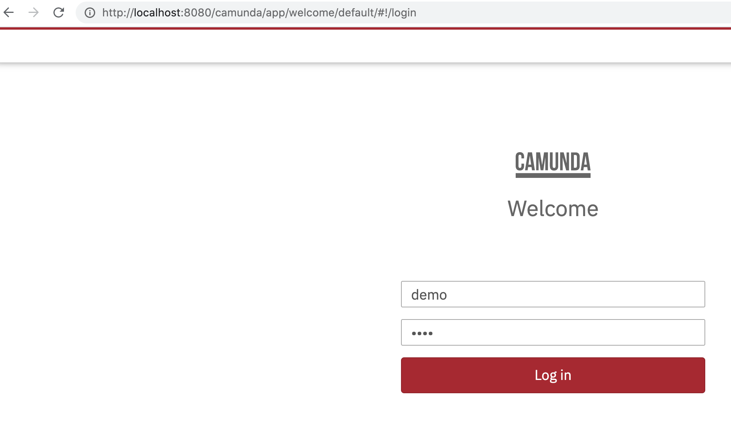

Camunda welcome screen will look as shown in above image. Enter the default credentials as given below.

**Username:** demo

**Password:** demo

demo user has admin role by default.

Once you sign in to the app, you will see different tabs for performing various tasks to start with the business processes.

* Hit the below url in the browser

http://localhost:8080/camunda/app/welcome/default/#/welcome

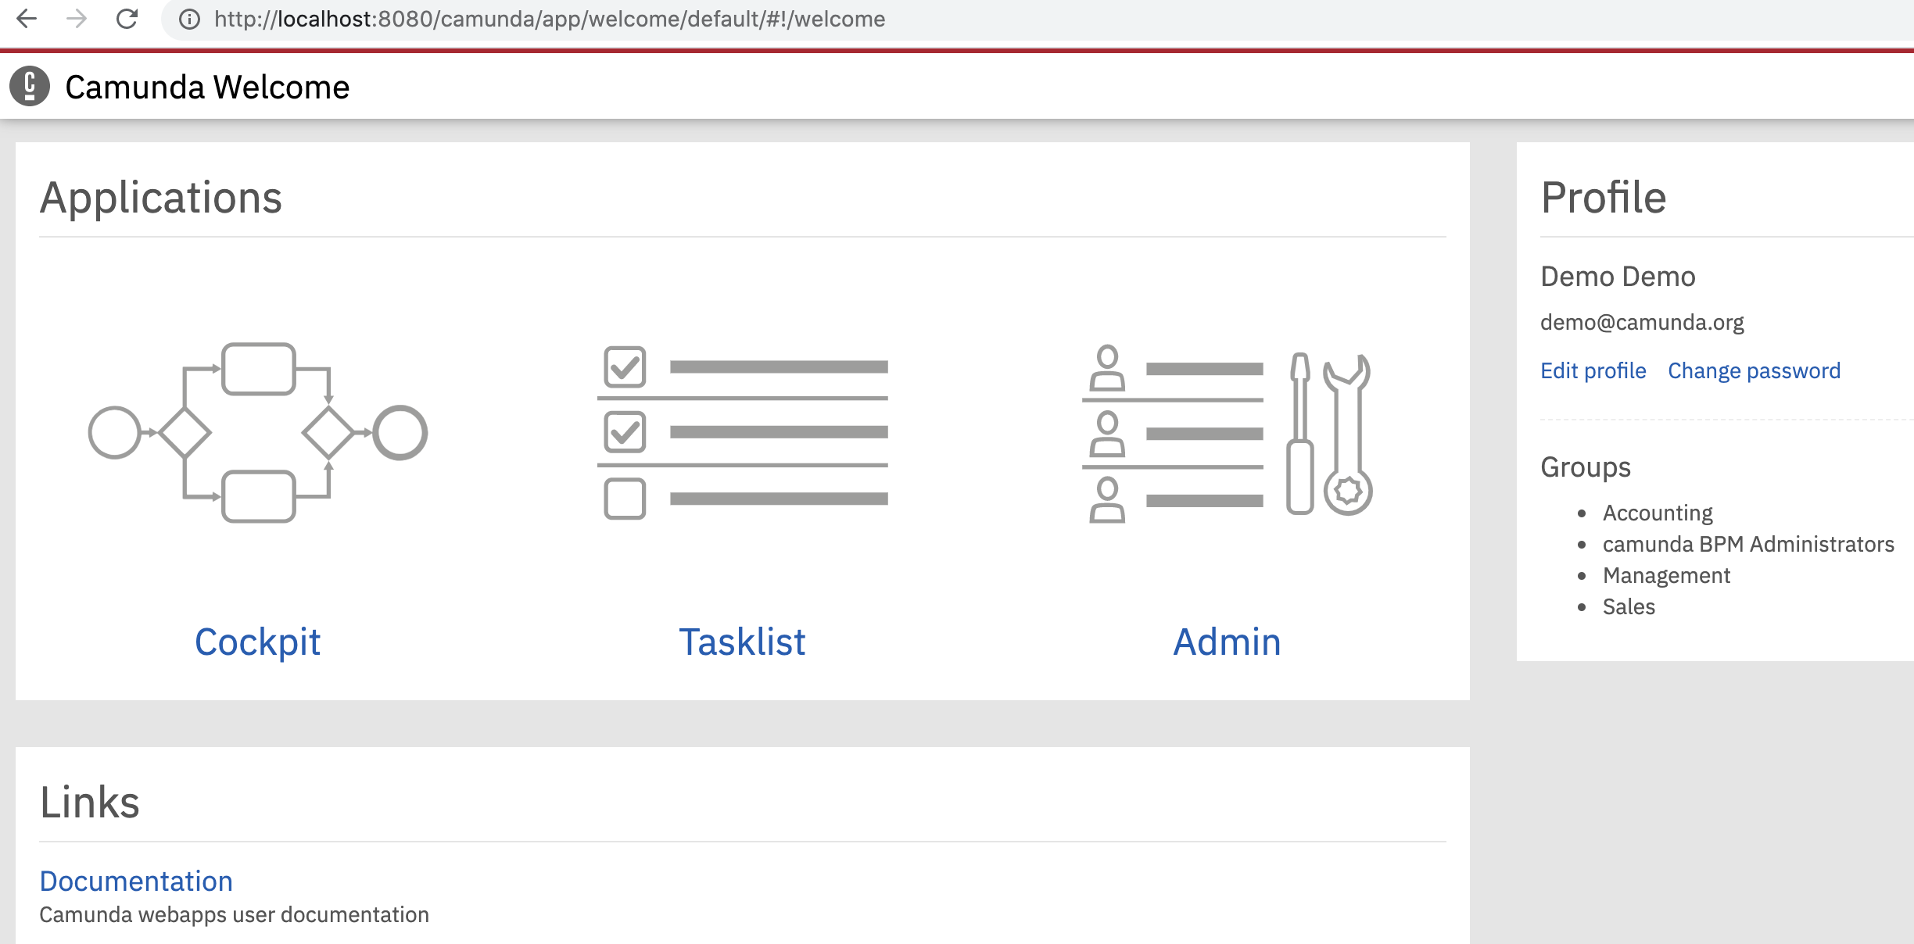

Camunda is running on web server apache-tomcat-9.0.5.

**Server Log:**

To get the server logs, errors or any status regarding the deployer you can find in the following directory:- ~/camunda-bpm-tomcat-7.14.0/server/apache-tomcat-9.0.5/logs

# **Camunda Modeler**

The next step is to start designing of the business processes using the camunda modeler. To start the modeler go to the directory where you have extracted the zip file and you will find the camunda-modeler.exe.

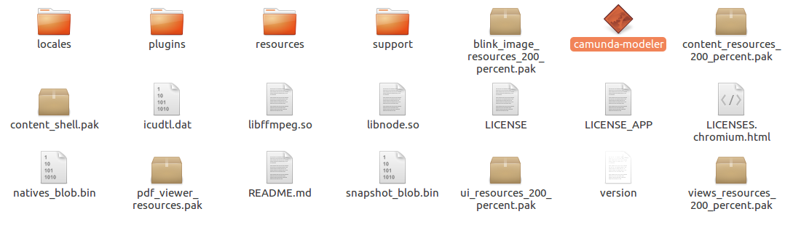

Double click on the selected file and you will get the screen as follows.

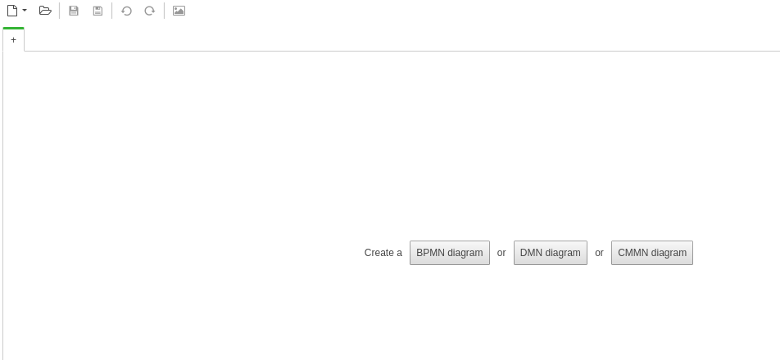

You can create the BPMN(Business Process Management Notation) diagram or DMN(Decision Model and Notation) diagram or CMMN(Case Management Modeling and Notation) diagram.

Now you are ready to get started with the designing of business process and deploy on the server.